OVERALL PROGRAMME EVALUATION REPORT
SBVP ALUMNI MASTERCLASS - SCALE Module I Online Kenya (20th April 2026 - 24th April 2026)
No. of Respondents: 195
No. of Participants: 195
Response Rate: 100%
--------------------------------------------------

Faculty Reports

Dr. William Murithi - Business Plan reviews
Evaluation Parameter | (%) Individual Score | (%) Programme Average
Punctuality (Commencement and Completion of Sessions) | 98 | 96
How well do you understand the core concepts presented? | 90 | 90
Rate your confidence in applying the new skills learnt | 88 | 84
Degree of Faculty preparedness for the sessions | 95 | 94
Content and methodology of the program | 95 | 93
Quality of class and group discussions | 90 | 90
The information presented in the course is relevant to my work (ministry) | 90 | 93
Average scores | 92 | 91

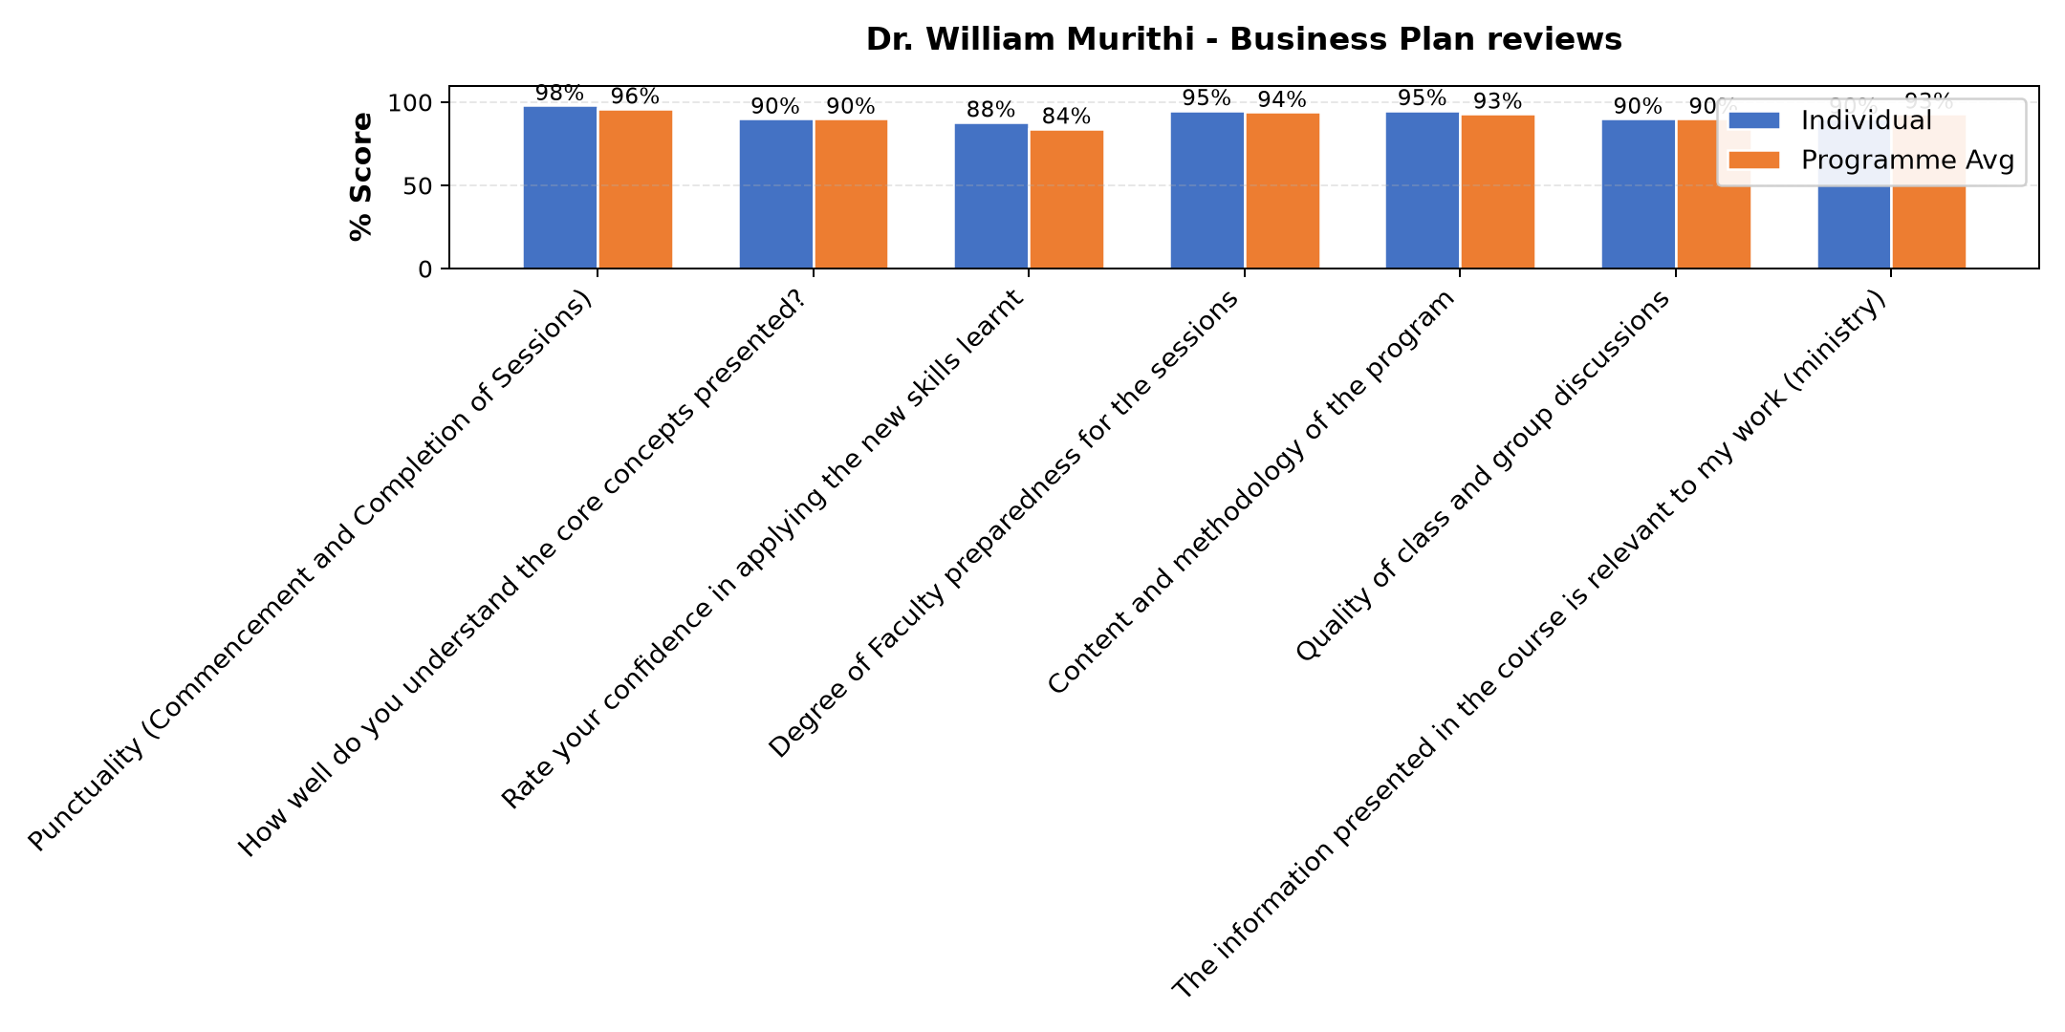

Comments & Feedback
- • None that I know
- • Organisational structures
- • The fear of failure due to luck of collaboration over competition.
- • Time
- • Limited resources
- • Lack of resources

Lenah Gachoki - Customers and competitor evaluation || Market potential evaluation || Customers, competitors and market planning
Evaluation Parameter | (%) Individual Score | (%) Programme Average
Punctuality (Commencement and Completion of Sessions) | 96 | 96
How well do you understand the core concepts presented? | 89 | 90
Rate your confidence in applying the new skills learnt | 85 | 84
Degree of Faculty preparedness for the sessions | 93 | 94
Content and methodology of the program | 94 | 93
Quality of class and group discussions | 92 | 90
The information presented in the course is relevant to my work (ministry) | 92 | 93
Average scores | 92 | 91

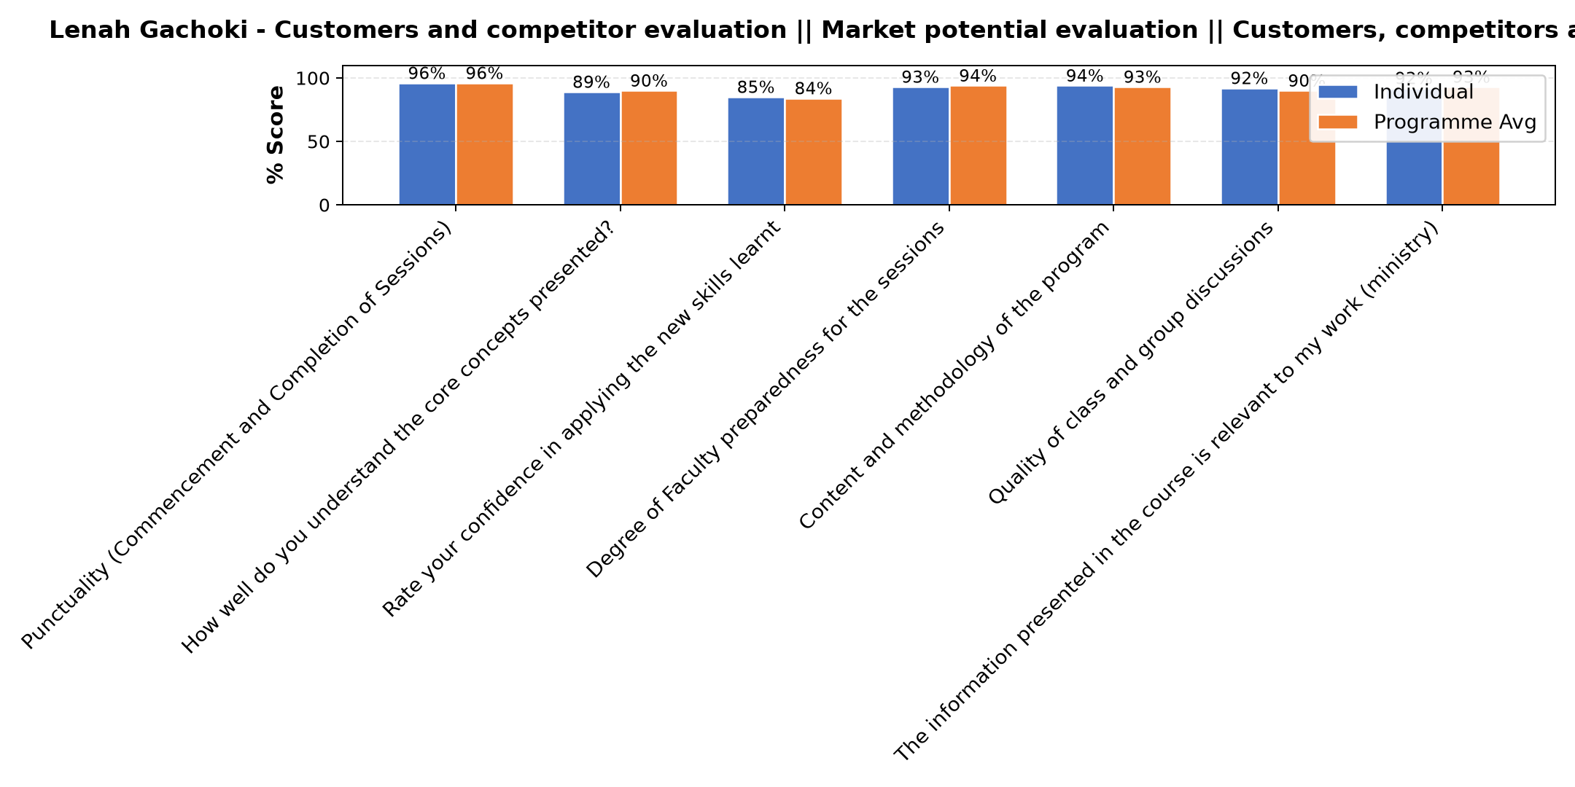

Comments & Feedback
- • Not that I know of
- • Resistance to change, lack of structure and support
- • It needs a lot of keeness, and time, growth is gradual, it's not one day thing
- • So far no barriers. We will try our best
- • Perception of the people
- • The barrier might be if am unble to identify my dominant color and work on it in order to balance with the others.
- • Finance
- • Personal challenges
- • I have to be aware of who I am inorder to help others however it will take time for them to understand how and why I do what I do but I believe with time we will be able to have a common understanding
- • Lack of courage
- • Lack of confidence
- • Well done
- • Luck of resources .Luck of proper technology and financial support.

Loise Wanjiru Oburu - Reflect on Vision and Mission || Reflect on charism || Identify alignment to social enterprise
Evaluation Parameter | (%) Individual Score | (%) Programme Average
Punctuality (Commencement and Completion of Sessions) | 96 | 96
How well do you understand the core concepts presented? | 92 | 90
Rate your confidence in applying the new skills learnt | 85 | 84
Degree of Faculty preparedness for the sessions | 94 | 94
Content and methodology of the program | 92 | 93
Quality of class and group discussions | 90 | 90
The information presented in the course is relevant to my work (ministry) | 92 | 93
Average scores | 92 | 91

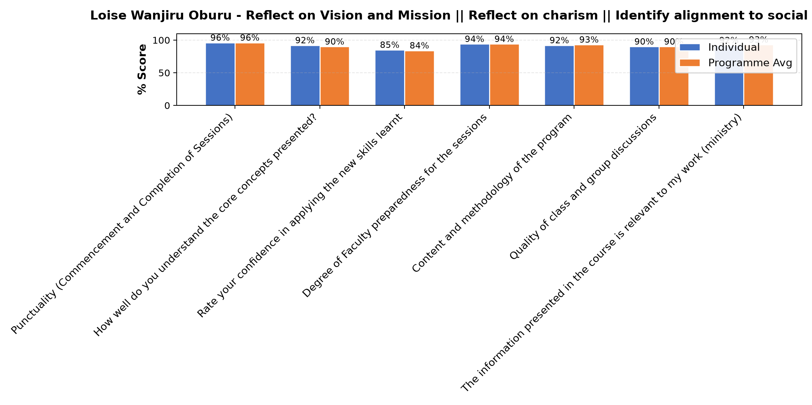

Comments & Feedback
- • Inadequate resources
- • Threats from the competitors
- • Sufficient funds for mplement action.
- • Lack of readily available finances to speed up the process
- • I would love to implement it but time is a barrier in that I will have to wait till end of the year when learners are away for 2 months
- • Interference from the leaders
- • Not that I know of
- • Proper action plan
- • Luck of define specific measurable of projects and financial problem.
- • Her approach is good tho so much on money making than evangelisation
- • Limited funds
- • Support
- • Resources

Dr. Cathy Mbidde - Reflection and leadership and teams (employees)
Evaluation Parameter | (%) Individual Score | (%) Programme Average
Punctuality (Commencement and Completion of Sessions) | 97 | 96
How well do you understand the core concepts presented? | 89 | 90
Rate your confidence in applying the new skills learnt | 82 | 84
Degree of Faculty preparedness for the sessions | 92 | 94
Content and methodology of the program | 93 | 93
Quality of class and group discussions | 87 | 90
The information presented in the course is relevant to my work (ministry) | 94 | 93
Average scores | 91 | 91

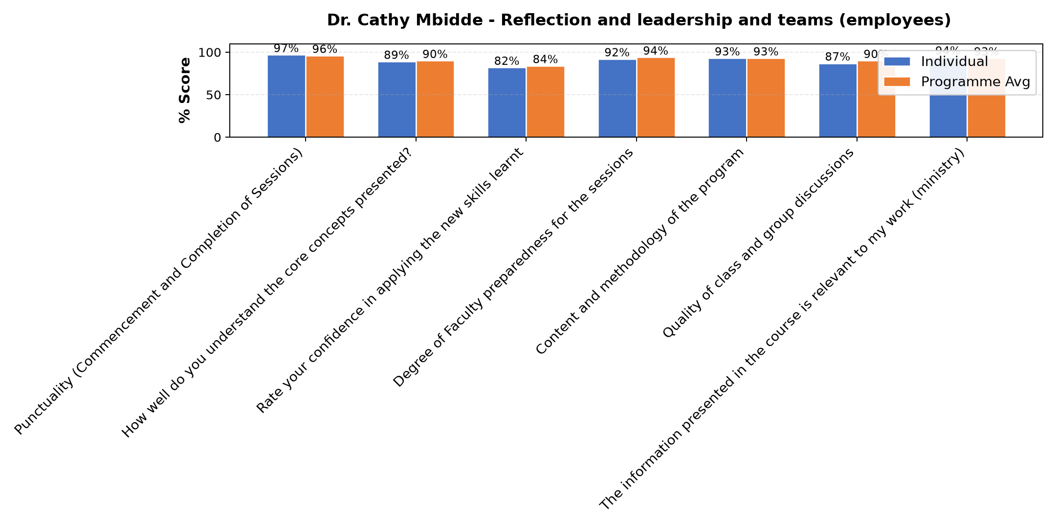

Comments & Feedback
- • Lack of implementation support and financial constraints
- • May be it is me who will fail to put into practice what I have learned today.
- • Review the vision, mission and core values of our institute.
- • Resources
- • The consent from the Authority
- • The structures of our life
- • We have learned that our vision,mission and core values should be precise and easily understood by other people. I foresee some resistance from our leaders since the vision , mission and core values are in most of our documents
- • Lack of confidence.
- • Time constraints
- • Nothing
- • Do not dare to take a risk
- • Ever changing staff in implementing the vision, mission, charism and core values thus a need for continued retooling workshops

Dr. William Murithi - Reflection of SEP Learning
Evaluation Parameter | (%) Individual Score | (%) Programme Average
Punctuality (Commencement and Completion of Sessions) | 95 | 96
How well do you understand the core concepts presented? | 88 | 90
Rate your confidence in applying the new skills learnt | 80 | 84
Degree of Faculty preparedness for the sessions | 94 | 94
Content and methodology of the program | 92 | 93
Quality of class and group discussions | 89 | 90
The information presented in the course is relevant to my work (ministry) | 95 | 93
Average scores | 90 | 91

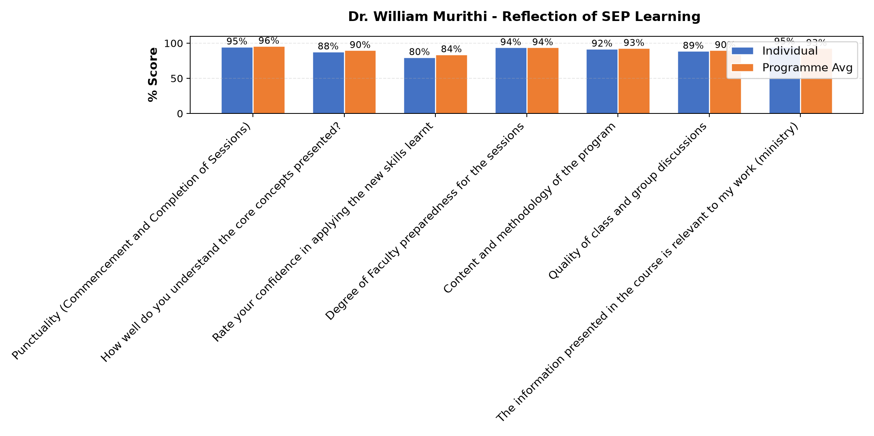

Comments & Feedback
- • The challenges that I might encounter in our social enterprise.
- • Finance
- • Lack of support systems
- • Limitation of time.
- • Distance
- • Lack of experience
- • Financial crisis
- • Financial resources
- • Resources
- • Financiall constraints
- • Financial constraints, when sharing the ideas to the other congregational members, not easy to accept change. Especially in the area of looking for other Financial streams
- • Lack of resources
- • The challenge of lack of enough finances remains a challenge to achieve my dream
- • Limited resources financially and Government regulations
- • The network barrier
- • Lack of support and inadequate finances

Department Reports

Further Comments

Comments & Feedback
- • Very educative program
- • I was touched when you shared about one is to identify key expenses associated with running the business. Very important thank you Dr. William.
- • The facilitator had good insights on Business Plan which was elaborated well and easy to understand.
- • Poor network
- • Thanks so much for Dr. Muriithi for the inputs, thanks to Strathmore team, Sr. Felistas and your colleagues. Grateful to Hilton Foundation
- • I appreciate the enlightenment and capacity building

Further Comments

Comments & Feedback
- • Thank you for the session
- • Am in Kenya-Tana River County, the net work is unsteady and this disconnected the sessions on and off. Please send us this notes via email so that we can read off line. Thanks
- • The presentation can be repeated another time by the same facilitator.
- • All that we do in our various social enterprises has to be aligned with our charism
- • To reach to one of the goals I need enough infrastructure in our social enterprise for more students enrollement
- • Overall,the training is an eye opener for sustainability
- • I understood better the correlationship between vision, mission, core values and subsequently the goals and objectives of any enterprise! When it is clearly articulated it is easier to get people to work towards it's, achievement!
- • This session help me to understand better and to reflect more profoundly on the Vision, Mission & Core values of our Congregation and Social enterprise. Thank you very much.
- • Grateful for the course, it was timely and well presented
- • Very Enlightened
- • Excellent work has been done. To be invited again for more input.
- • We will try to align our social enterprise with the the congregation charism, vision, Mission, goals and objectives
- • It was a powerful input. Blessings to our Facilitator

Further Comments

Comments & Feedback
- • I like the passion and energy of Lois! She has the ability to challenge you towards higher goals etc! She is an excellent mentor that can indentify untapped potentials and spurs one to action!
- • A good challenge by Dr. Oburu though tough truth of what we could be doing
- • God to help us ,to implement our business plans, and be able to change our attitude and mindset
- • Excellent facilitator who wants to hear work has been done I our social enterprises has planned.
- • It was so interactive I appreciate
- • Her tough way of teaching brought tension at the beginning though she is passionate
- • A very challenging class I loved it
- • Awakened strongly
- • Lesson was very interesting and applicable
- • Thank you for the input we have received we improve theour projects. We're to be mind set.
- • She need to be made aware that our mission is evangelization as we get the money. In health care we can not send a patient away simply because she can't pay admission fee. Otherwise she is helping us be one strategic and excellent leaders
- • Thank you

Further Comments
Evaluation Parameter | (%) Score
Punctuality (Commencement and Completion of Sessions) | 100
How well do you understand the core concepts presented? | 60
Rate your confidence in applying the new skills learnt | 80
Degree of Faculty preparedness for the sessions | 100
Content and methodology of the program | 80
Quality of class and group discussions | 60
The information presented in the course is relevant to my work (ministry) | 80
Average score | 80

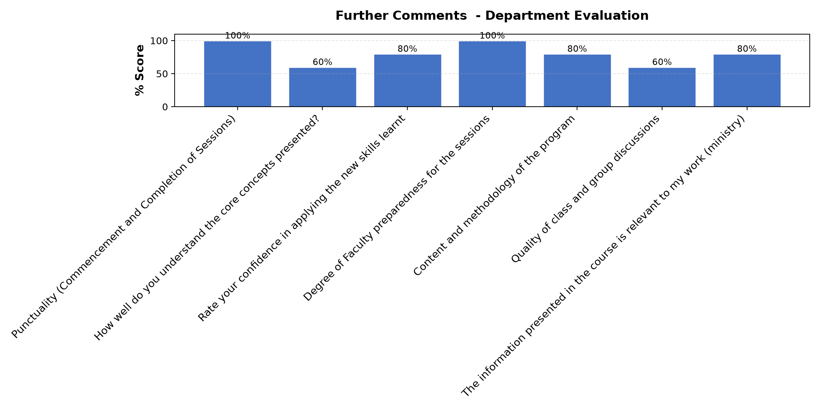

Comments & Feedback
- • Very motivated sessions. Wish we could have more time to elaborate more.
- • I need more skills on Fundraising
- • Lack of resources
- • The session was very interactive. Thanks
- • It was Excellent
- • The sessions were well reflected and enriching to pull up our social enterprise.
- • Look for other sources of getting money
- • The class was very interactive
- • Thank you
- • Network instability in Tana River county
- • The group discussions were very enriching and encouraging. Thanks.
- • Grateful for the opportunity
- • But this programme has made me not to fear lack of finance but to work on how to get it
- • I am grateful for this chance, feel appreciated, together we can
- • The interaction was very encouraging and informative
- • Collaboration over competition. Transformations a person from wanting just to give, but to know how to empower others to solve their own challenges.etc .The sharing was good and we enrich one another.
- • Thank you for the enlightenment
- • I am learning important things about myself
- • The presentation was very interesting and quite interactive
- • Good presentation
- • Need to be helped in marketing strategies
- • I understood the content even better this time than before! It is so important for any enterprise because the personality of the leader can either make or break the enterprise.. There is possibility of better self awareness and of enriching the personality by working on the weak aspects. More time should be given t this
- • Thank you for the enlightenment and reminder of self introspection
- • It's enlightening and encouraging, I encourage if every sister can undergo the same , not only those who are leader or managers in different apostolates
- • Thank you so much for the input
- • If possible the facilitator to be engaged and sensitize members of our congregations.
- • Work to adapt and balance my colors with others in my daily life.
- • The facilitation was good. Let her ( Dr Loise) visit our enterprises and see the reality on the ground and them she can advise accordingly.
- • Thank you.
- • Thank you very much for helping me understand myself better and also know what weakness I need to work on.i liked the openness from the members
- • Knowledgeable and friendly facilitator
- • With the knowledge l have learned lt can help us on how to improve.

Overall Evaluation
Evaluation Parameter | (%) Score
Overall program evaluation | 95
Average score | 95

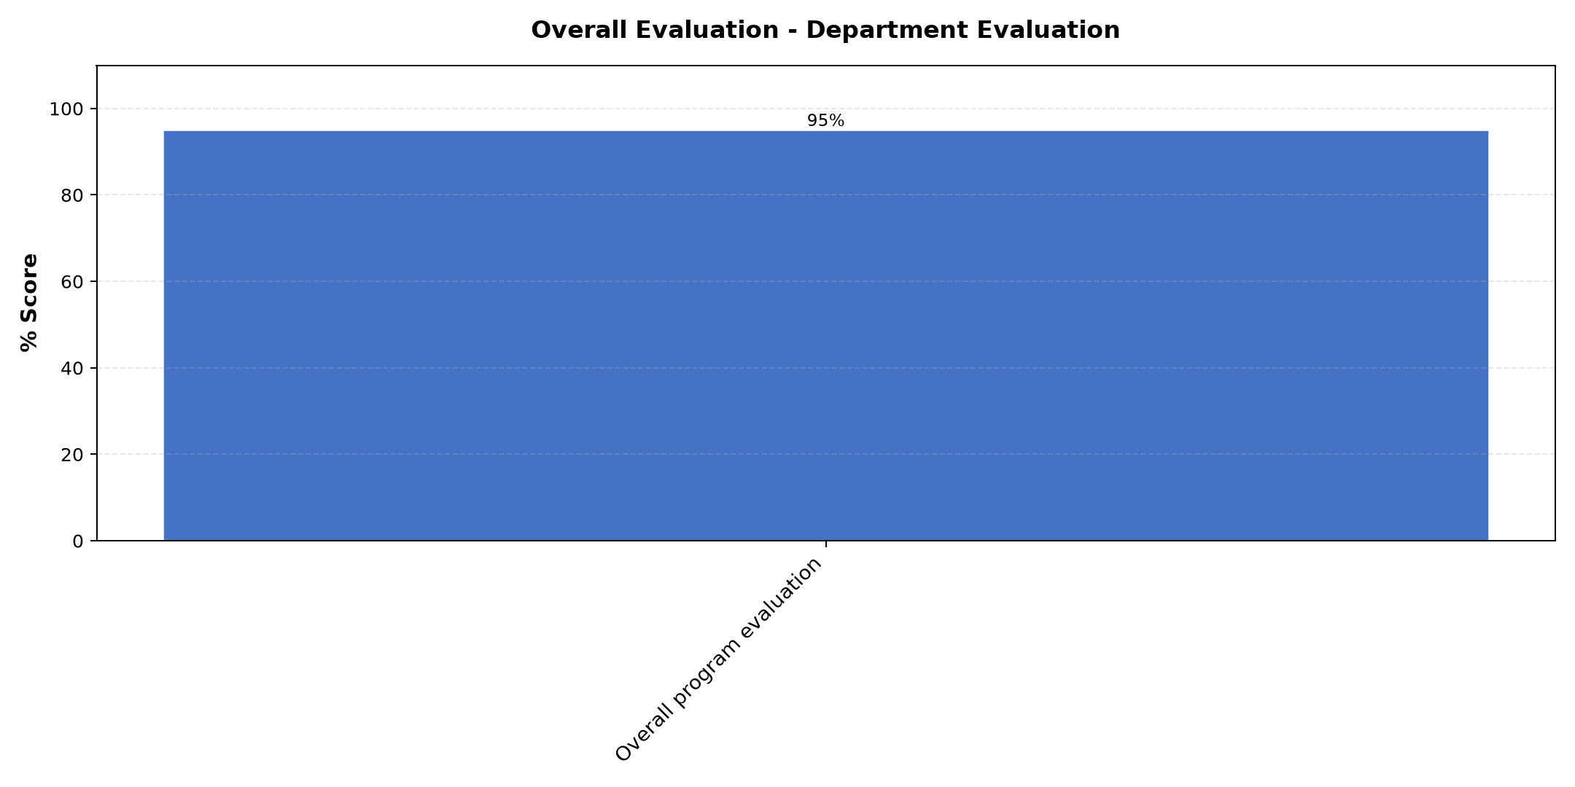

Comments & Feedback
No comments recorded.

Program Manager (Paul Bikundo)
Evaluation Parameter | (%) Score
Punctuality in sending materials and programme information | 94
Communication skills(verbal and written) | 100
Response to programme enquiries via email, whatsapp and calls | 97
Accessibility and willingness to support when needed | 100
Quality of service / professionalism | 100
Average score | 98

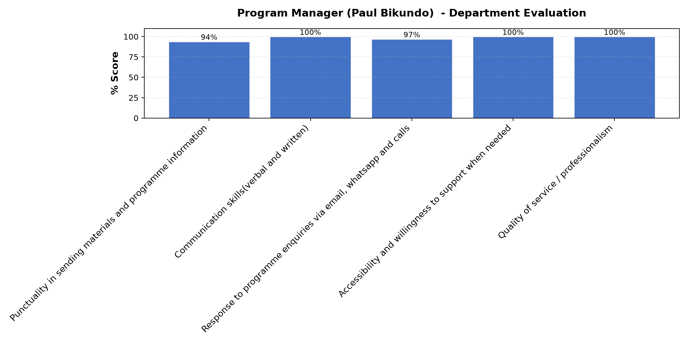

Comments & Feedback
- • Keep it up
- • Thank you so much for coming up with this follow up course that has afforded the opportunity to evaluate and project into the future through concrete decisions! Very commendable
- • Social interprise programme has me empowes to foster mission drive mindset.
- • Excellent work.
- • He is very good
- • Job well done

What attracted you to the programme??

Comments & Feedback
- • Nominated by the congregation leadership
- • Our desire to make our social projects sustainable
- • What attracted me to the programme, it has helped me to know on how finance planig for social enterprise on the many activities we do.
- • New ideas on business canvas.
- • Ability to learn how to transform our social enterorise
- • The enthusiasm of the teachers
- • Need to broaden my knowledge on managing and sustainability of our congregation projects
- • Nomination by the administrator

What topic would you recommend being expanded/improved in this programme’s units?

Comments & Feedback
- • Business Plan
- • Marketing, leadership,
- • For now l can say the programme is well arranged and the materials were well represented and clear.
- • Aligning our charism to the social enterprise. Coming up with SMART objectives.
- • Customer and competitors Evaluation
- • 1. Customers and competitors evaluation 2. Aligning of of vision and mission to social enterprise
- • Business planning

Which areas in this programme did you find most important to your social enterprise?

Comments & Feedback
- • Sustainability
- • Marketing:evaluation of what has been done and feed back; clarification of the vision, mission andcore values= goals and objectives, leadership
- • To develop a marketing plan and have a financial plan ect.
- • All areas covered were so crucial and connected well. You can not do without vision&mission, leadership and Business canvas.
- • Business plan
- • Business plan
- • 1. Customers and competitors evaluation 2. Aligning of of vision and mission to social enterprise 3. Business plan and reviews

Which teaching methods applied in the course did you enjoy/learn from the most?

Comments & Feedback
- • Illustrations
- • It was student focused(honest sharing) feedback from the lecturers: acknowledged work done, encouraged, challenged and pointed out unseen potentials
- • The way the input was given and explanation was methodically.
- • Question then you present.
- • Lecture
- • From the experiences of the others
- • Lectures and group sharing
- • Discussion and reflections shared

Are there any other comments and/or suggestions that you may want to add?
Evaluation Parameter | (%) Score
Punctuality in sending materials and programme information | 100
Communication skills(verbal and written) | 100
Response to programme enquiries via email, whatsapp and calls | 100
Accessibility and willingness to support when needed | 100
Quality of service / professionalism | 100
Average score | 100

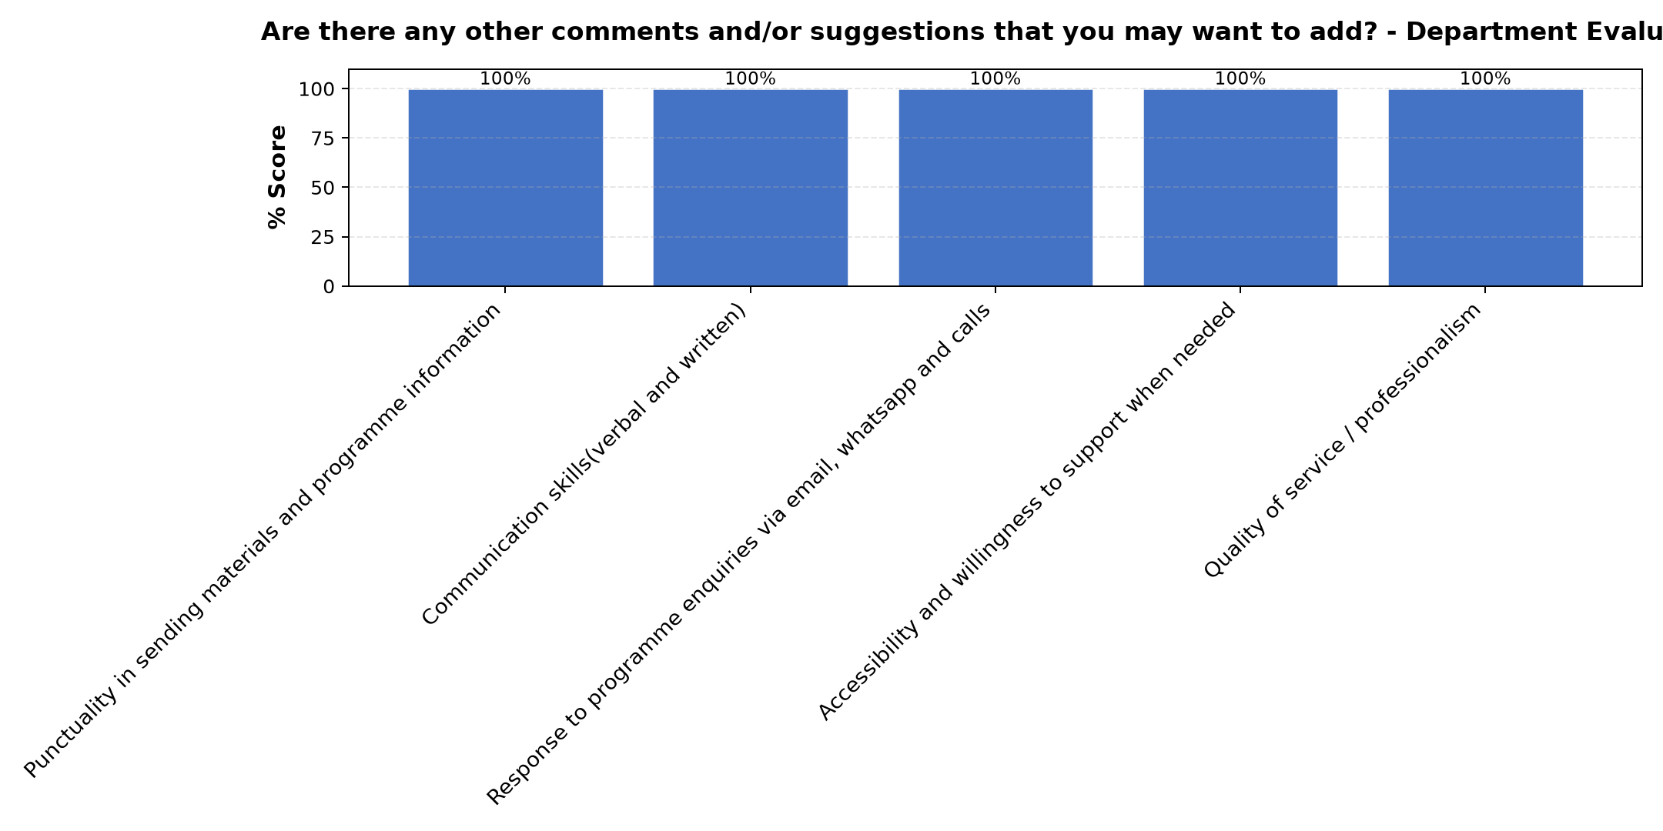

Comments & Feedback
- • Every facilitator was well prepared for their presentations
- • Thank you so much Paul your work is excellent. But some places we have a problem of network barrier. Be blessed.
- • Appreciation to Acweca and Strathmore team for the knowledge we have acquired to strengthen our social enterprises and sustainability.
- • The readiness of the facilitators was commentable ,we are grateful

